# Manual Configuration and ACP Document

1. **ACP - 1 (**Estimated time: 30 min**)**

**File name**: 1_List_PX_AutoNumber



Ignore the warnings and errors listed in below file as they are taken care in next steps



Manually login to Java client and check whether all configurations are propagated correctly or not.

1. **Manual Configurations on Change Orders and Change Requests Classes,Smart Rules,Roles (**Estimated time**:** 45 min**)**
   1. **Change Orders Class**
      1. Change Orders.Cover Page.Number - Modified Character Set from Include Characters From All Characters without space and Upper Case To All Characters without space and Mixed Case
      2. On Change Orders Page Two
         1. Create new attribute - List15 - Regulatory Notification Required?*

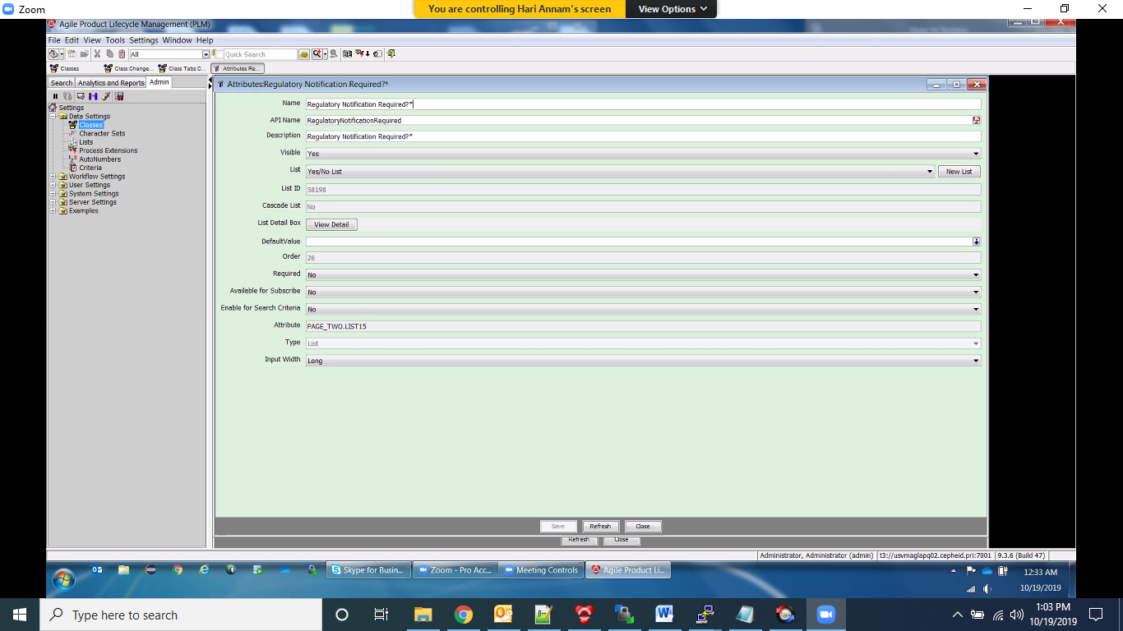

* + - 1. Create new attribute - MultiText36 – Justification

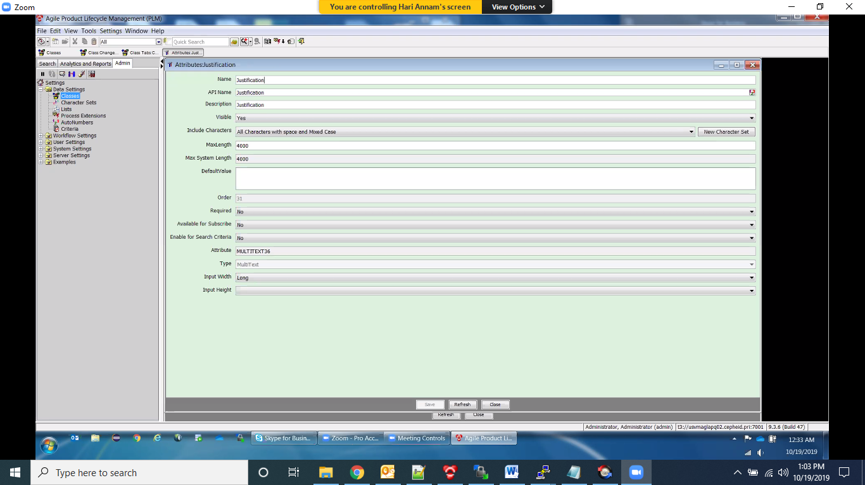

* + - 1. Create new attribute - MultiText37 – Comments

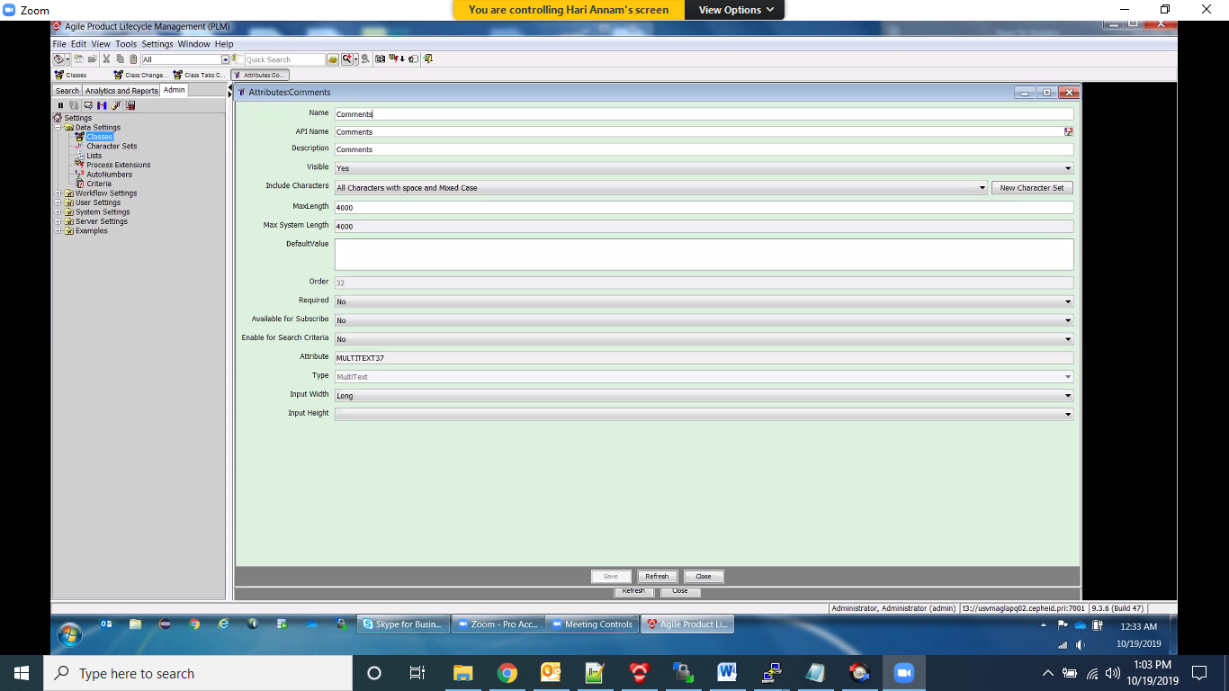

* + - 1. Create new attribute - List18 To Product Type*

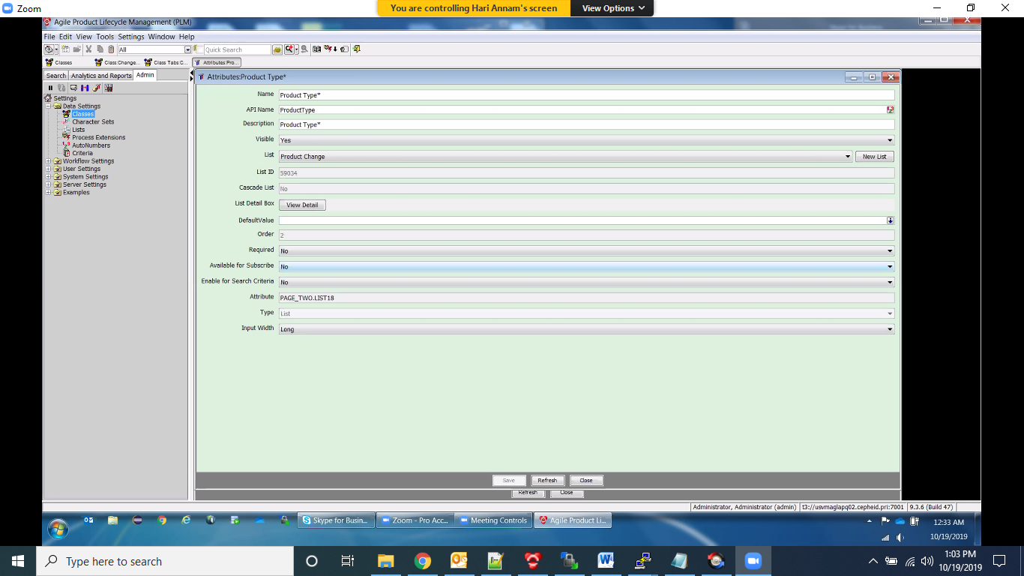

* + - 1. Create new attribute - multiList05 To Change Type*

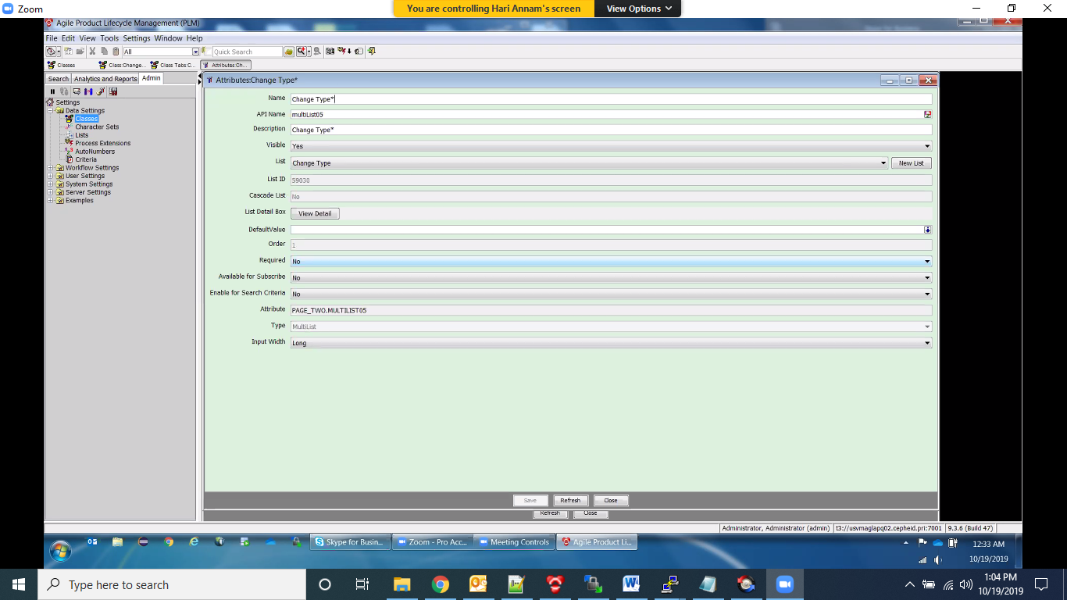

* + - 1. Create new heading - heading02 - Regulatory Notification Required Per Impact Assessment

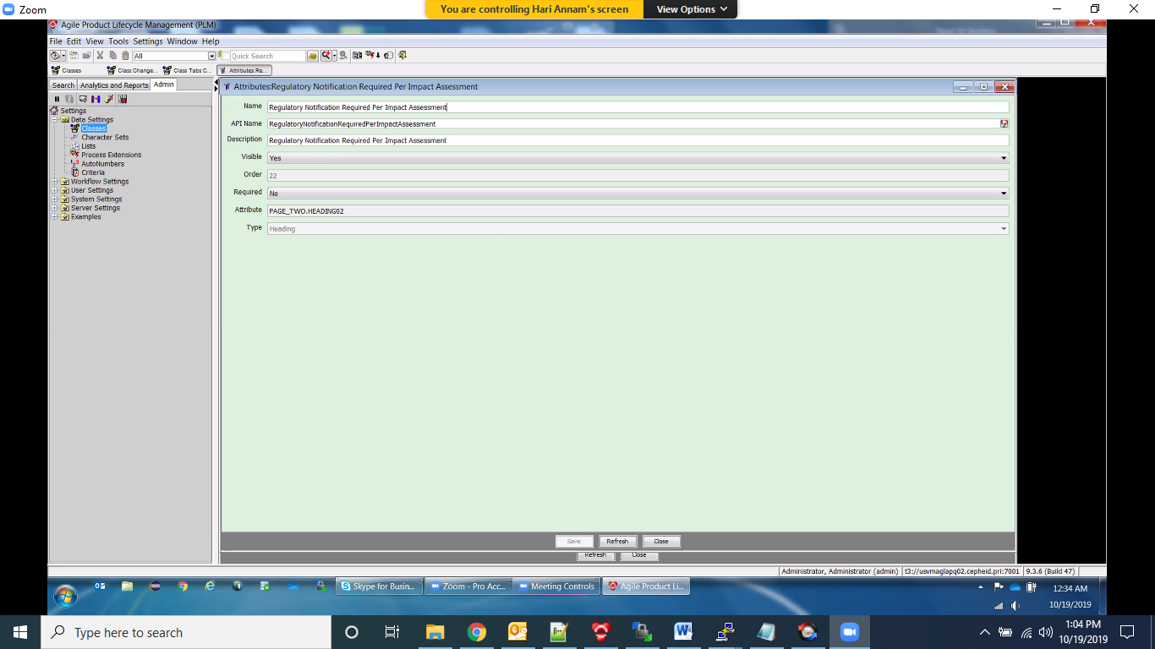

* + - 1. Order Page Two attributes on Change Orders like below

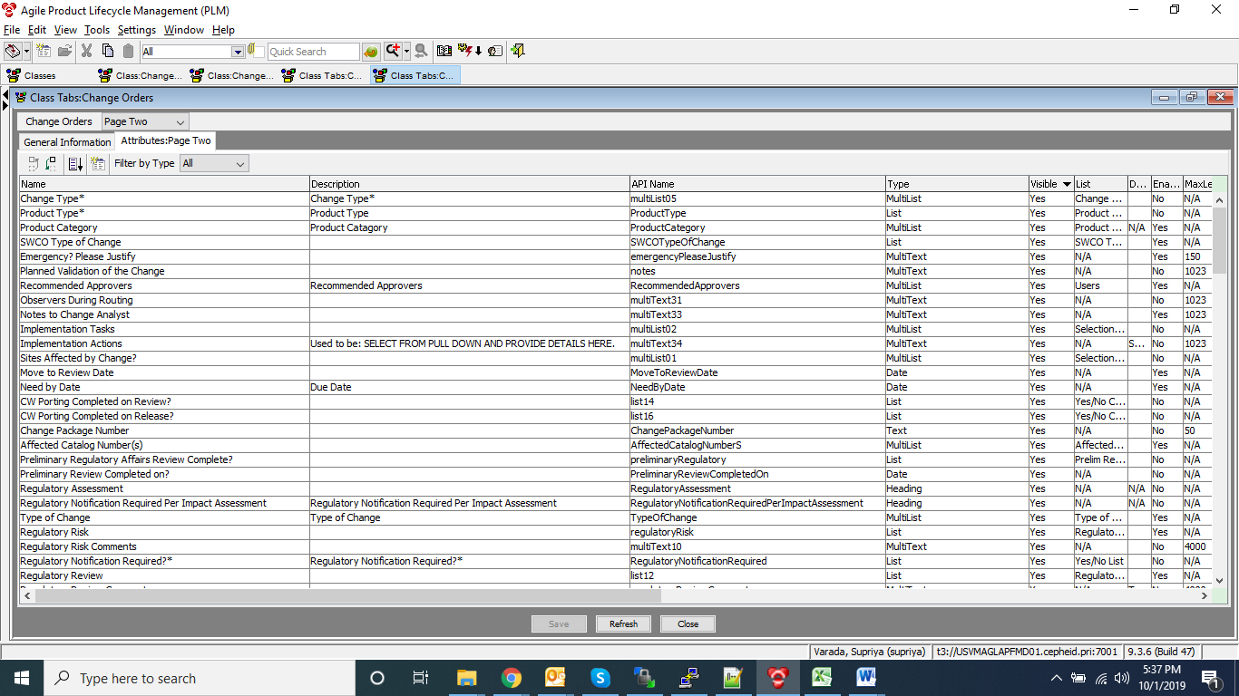

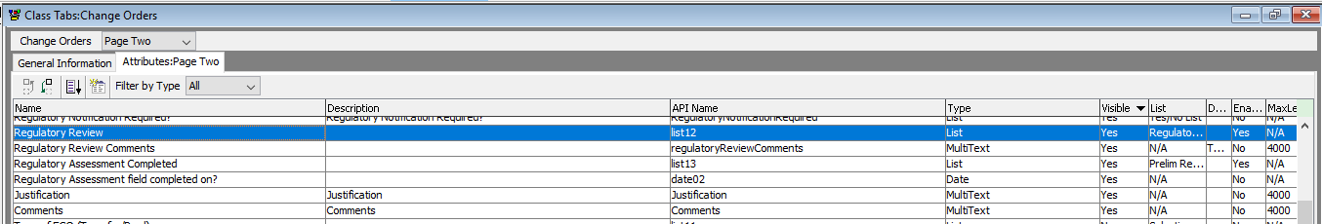

* + - 1. Disable below attributes on Page Two of all subclasses under Change Orders i.e., DCO,ECO, LRO-SP,NON CONTENT CHANGE,RCO,REF NON CEPH DOCS,SWCO,VWF.

1. Product Type*
2. Change Type*
3. Regulatory Notification Required Per Impact Assessment
4. Regulatory Notification Required?*
5. Justification
6. Comments
   * 1. On Change Orders.Cover Page , Modify Name From Product Type To Project/Product Category

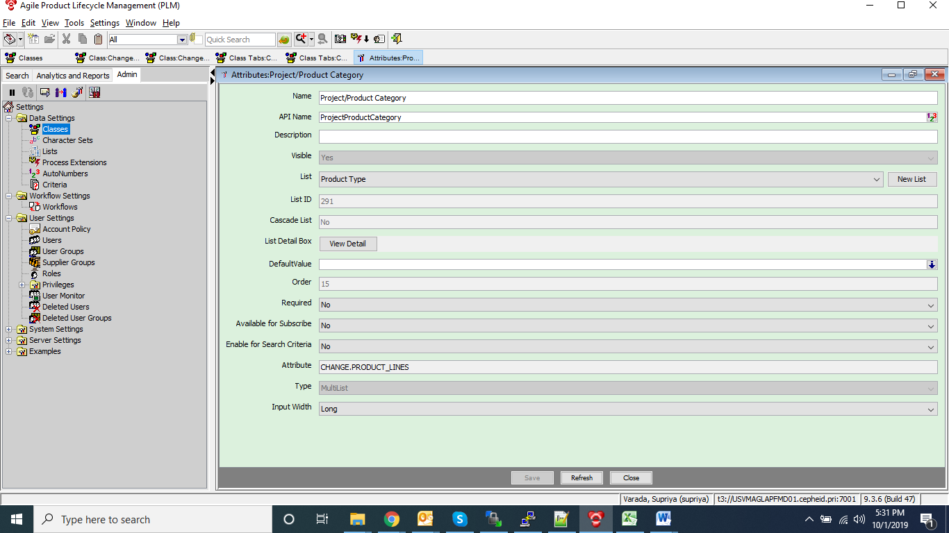

* 1. **Change Requests Class**
     1. Change Requests.Cover Page.Number- Modified Character Set from Modified Include Characters From All Characters without space and Upper Case To All Characters without space and Mixed Case
     2. Enable relationships tab on Change Request class

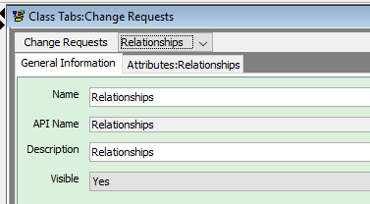

* + 1. Modify Reason For Change To Impact/Risk/Justification

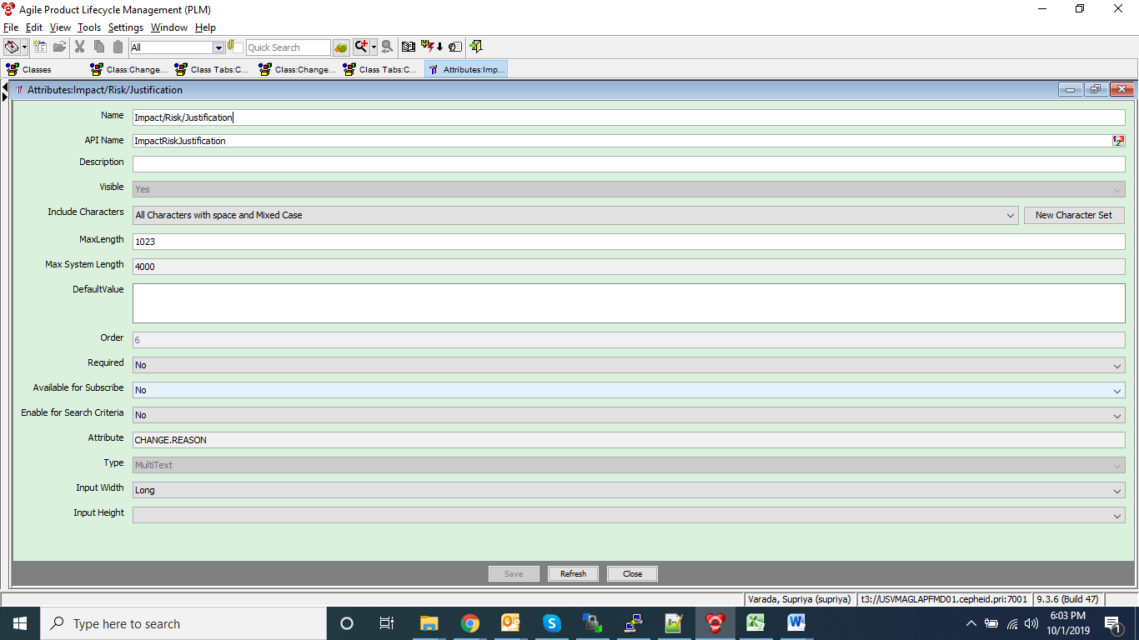

* + 1. Rename Solution/Change Description To Description/Reason For Change

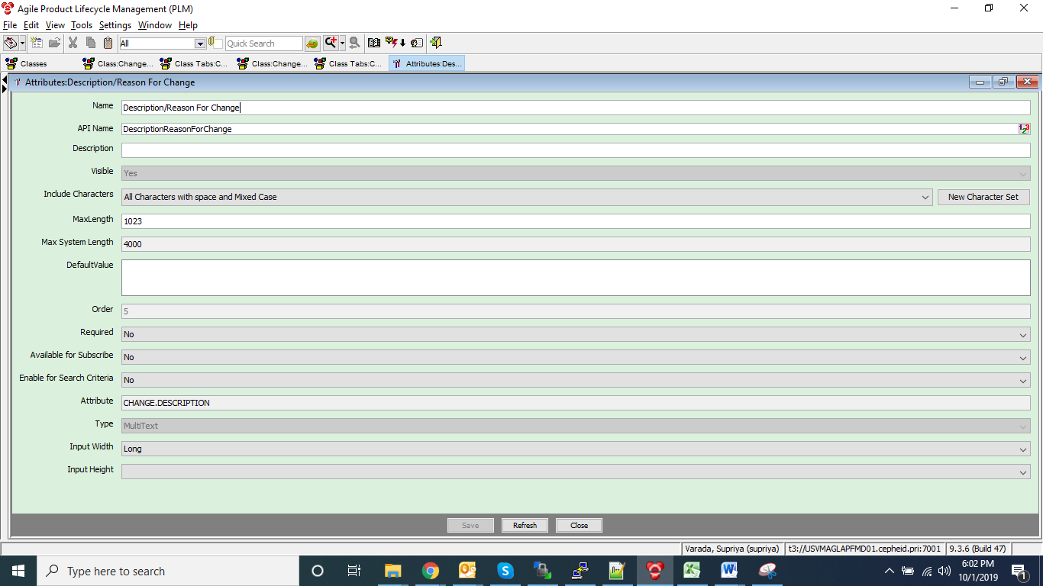

* 1. **Smart Rules**

Modify Change Status No Response From Acknowledger From Disallow To Allow



* 1. **Create a role “A9 Approver - AWF’’ as shown in below screenshot**

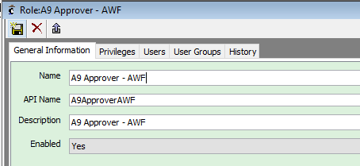

**Assign below user groups (highlighted in blue )to the role.**

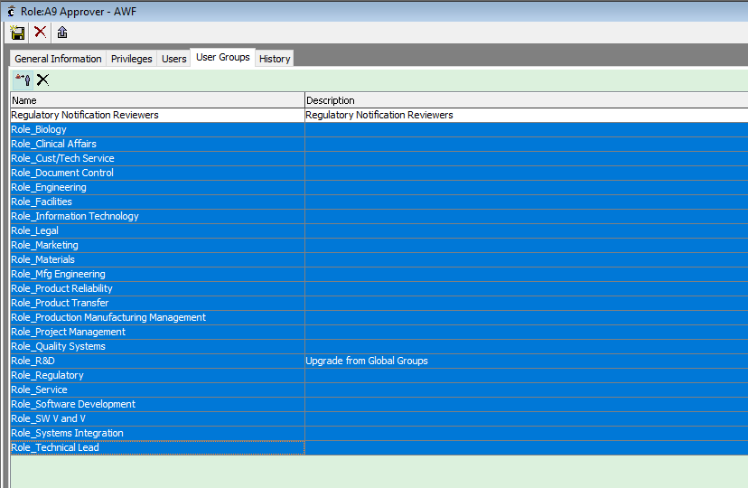

* 1. **Update below field to production URL in AWF Messages List**



1. **ACP -2 (**Estimated time: 30 min**)**

**File name**: 2_Subclasses



Ignore the warnings and errors listed in below file as they are taken care in next steps



Manually login to Java client and check whether all configurations are propagated correctly or not.

1. **Manual Configurations related to Subclasses (**Estimated time: 30 min**)**

**4.1** Enable Page Three tab on AWF and Verify all the Page three attributes are propagated successfully or not.

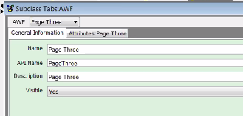

**4.2** Create below attributes

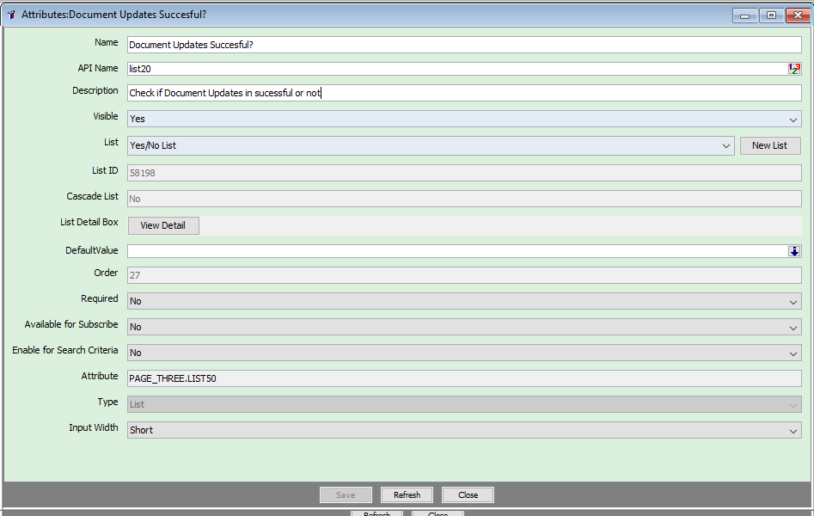

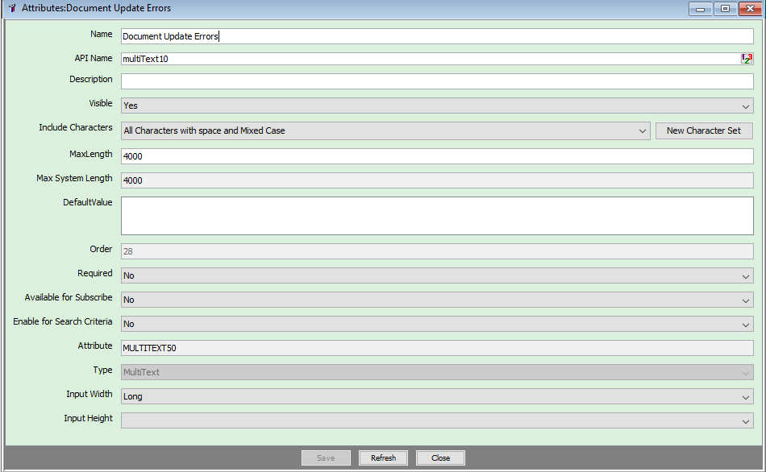

**4.3** On Page Two of AWF, make sure only below attributes are enabled, disable remaining attributes

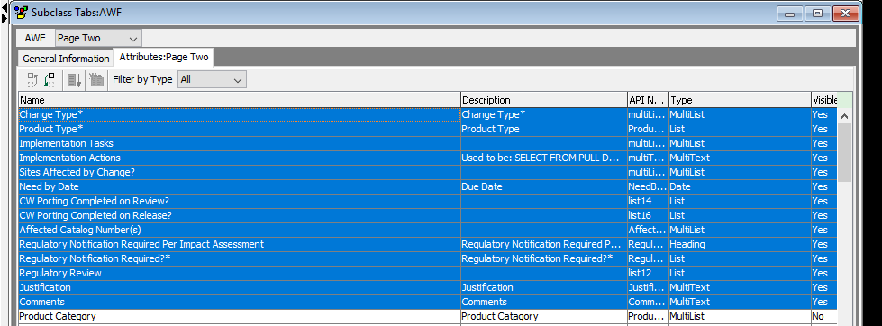

**4.4** Enable Page Three tab on eCR and also verify all the required attributes inside page three are enabled

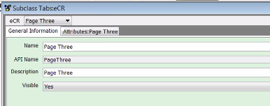

**4.5** Rename Page three heading for eCR

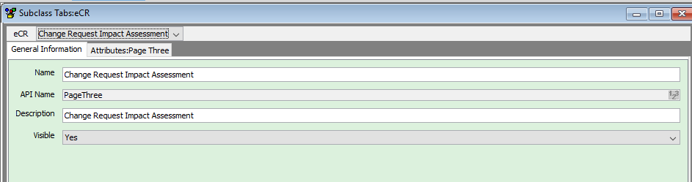

**4.6** Verify for all the page three attributes, list is assigned properly or not on eCR

**4.7** Open auto number - AWF Number and navigate to where used tab. Verify where used tab is mapped to AWF.

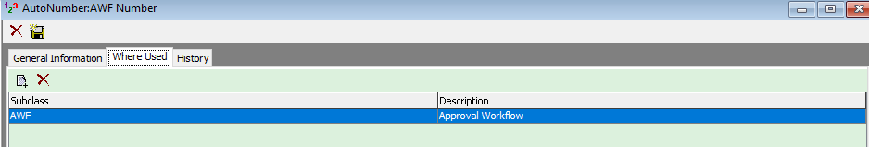

1. **ACP -3 (**Estimated time: 30 min**)**

**File name**: 3_WorkflowCriteria



Manually login to Java client and check whether all configurations are propagated correctly or not.

1. **Manual Configurations related to User Group and Workflows (Estimated time: 1 h 30 min)**
   1. Manually create below user group – Regulatory Notification Reviewers

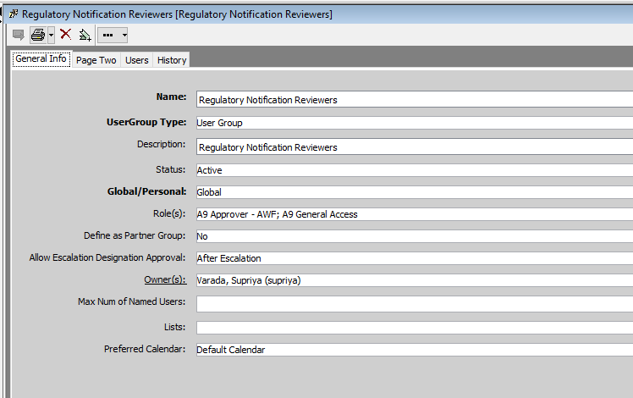

Add below users to the usergroup

Rowena Cook , Sarah Elision, Behera Sarjeeta, Viso Vanessa

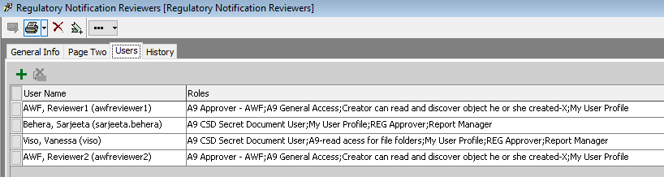

* 1. Manually configure AWF Workflow and eCR Workflow by referring to QA

1. **ACP-4 (**Estimated time: 45 min**)**

**File name:** 4_Criteria_Privileges



Manually login to Java client and check whether all configurations are propagated correctly or not.

**Also manually create/update below privileges/criteria based on dev.**



1. **Manual Configurations related to Privileges,Roles,Dynamic List (**Estimated time: 45 min**)**

**8.1** Check whether all the below roles are assigned with required privileges or not

1. A9 Approver – AWF
2. A9 Change Analyst
3. A9 Creator
4. A9 General Access

**8.2** Check below for role “A9 Approver - AWF”

1. Open the role “A9 Approver - AWF” and check all the below privileges are added to it after ACP

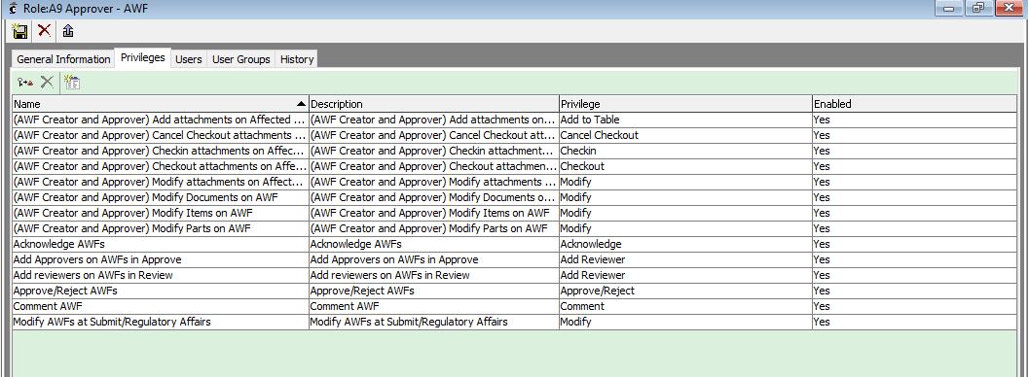

1. Open the role “A9 Approver - AWF” and check the user group “Regulatory Notification Reviewers” is added to it after ACP.
2. Add “A9 Approver – AWF” role to the below process extensions
3. Generate AWF

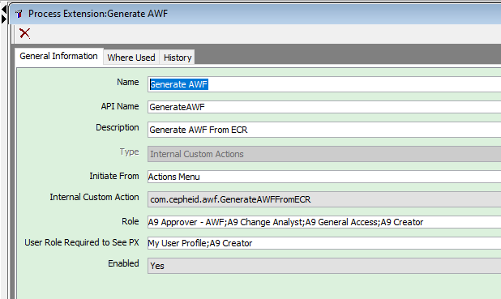

1. Generate VWF

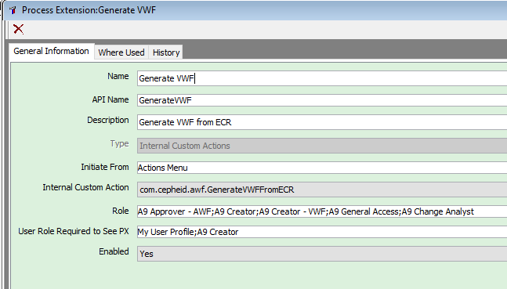

1. Generate DCO

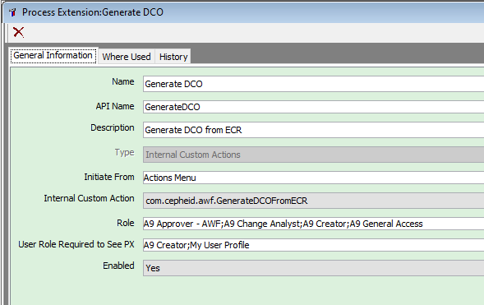

* 1. Create below dynamic list “Engineering Change Requests” manually

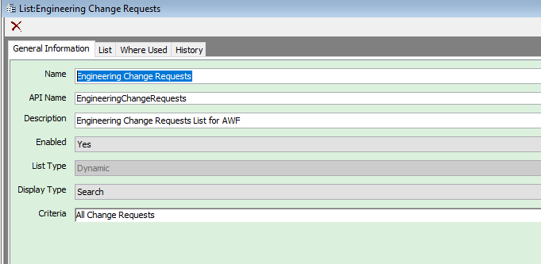

Assign the above list to below attribute

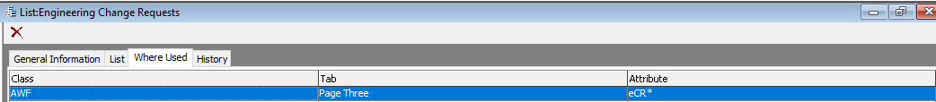

1. **Manual Configurations related to Workflow Events (Estimated time: 30 min)**
   1. Configure below events manually by referring to QA
      1. Set Reviewers on AWF
      2. Set Review Dates
      3. Change Status Event on AWF from Pending to Review
      4. AWF is Released
      5. AWF Is moved to Implement Review
   2. Make sure the scheduled event frequency is set to 12 AM everyday on weekdays and is enabled

**10 ACP -5 (Estimated time – 30 min)**

**File name**: 5_Event_Handler_Subscriber



Manually login to Java client and check whether all configurations are propagated correctly or not.

**11 New Configuration Changes POST QA migration (**Estimated time**:**30 min**)**

* 1. **Disable Save as for AWF and ECR**

**11.1.1** Remove the privilege “(Cepheid Creator and Approver) SaveAs Changes” from A9 Creator role.

**11.1.2** Create a new criteria “Save as Changes except AWF and eCR” as shown below.

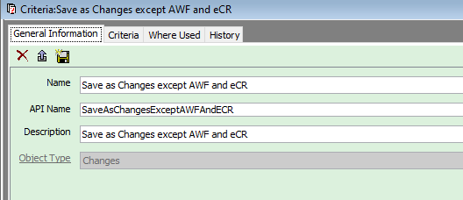

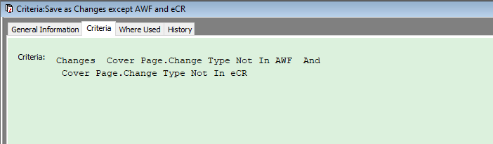

**11.1.3** Create a new privilege “SaveAs Changes except AWF and eCR”

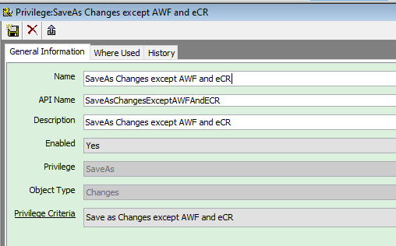

**11.1.4** Assign it to A9 Creator role

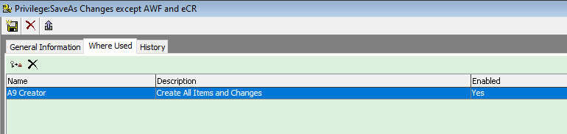

**11.2** Refer to the users who are added as Notify Upon entry on ECO/RCO workflow and add them to AWF Workflow.

**11.3** Create new role “Regulatory Affairs” by referring to QA

**11.4** Verify the impact assessment questions modified on eCR and AWF are migrated properly like in QA